|  |  |
| --- | --- |
| **Student Name** | **Student ID** |
| **ZHANG ZI TENG** | **TP052096** |
| **LEONG SOONG JUN** | **TP050994** |
| **TAN WEI XIAN** | **TP048417** |
| **LYU CHENG YANG** | **TP052020** |

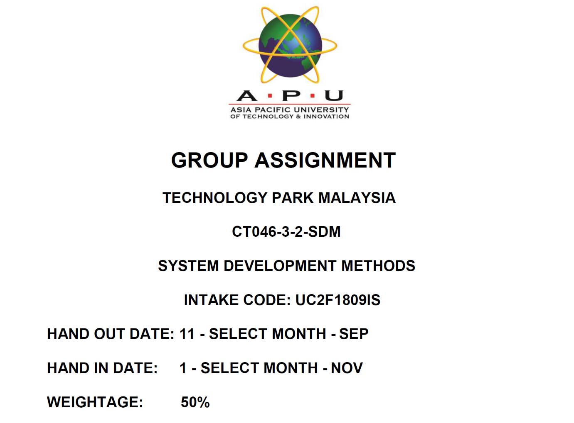

# Table Of Content

Table Of Content 2

Implementation and Deployment 3

Construction 3

Testing 5

Deployment 9

Individual 12

ZHANG ZITENG TP052096 12

Extreme Programming Methodology 12

Project Scheduling 16

LEONG SOONG JUN TP050994 17

Waterfall Methodology 17

Project Scheduling 20

LYU CHENYANG TP052020 21

Scrum Methodology 21

Project Scheduling 24

TAN WEIXIAN TP048417 25

WISDM Methodology 25

Project Scheduling 28

Reference 29

# Implementation and Deployment

## Construction

Nowadays, there are many kinds of programming language. In this system, mainly we are going to use two kinds of programming languages. The system is a phone base application, and there are two widely used system. We need to develop the similar system in two different systems. So, at least there are two kinds of programming languages going to be used.

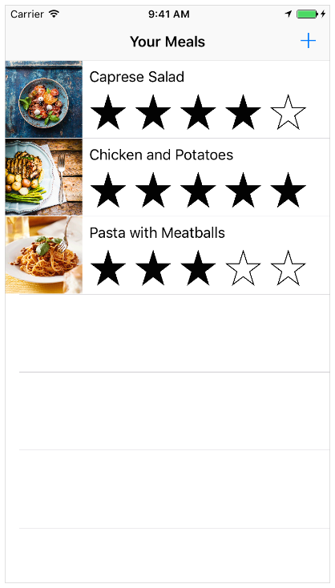Firstly, we are going to develop the APP for iOS by using Swift languages. Swift is a compiled, multi-paradigm, general-purpose programming language created by Apple Inc. for iOS, OS X, watchOS, tvOS, and Linux. It is an alternative to the Objective-C language that was the most common and recommended language for building apps for the mobile ecosystem of Apple. Compare to another programming language for iOS - Object-C, Swift is easier to learning, safety, requires less code, faster developing speed and interactive among other things. Other than swift, we also will use some client server languages, such as html, jsp, CSS etc.

Figure 1 Developer.apple.com. (2019). *Start Developing iOS Apps (Swift): Jump Right In*. [online] Available at: https://developer.apple.com/library/archive/referencelibrary/GettingStarted/DevelopiOSAppsSwift/index.html#//apple_ref/doc/uid/TP40015214-CH2-SW1 [Accessed 6 Dec. 2019].

The developing tools for iOS are Swift 5.1 and XCode. We can use XCode to develop the source code of the system and Swift to design the user interface of the system. For example, as you see in the figure 1. We can use Swift to build a simple meal-tracking app called Food Tracker. This application displays a meal list, such as the name, status, and images. The customer can insert, delete, or edit a meal after connecting to the source code. Consumers move to a separate screen to add a new meal or edit an existing one where they can assign a name, score, and image for a specific meal. All of these features are going to come true with the help of XCode.

Moreover, considering that Android users are also very large in the world. The APP for Android system will also be included in our plan. The interface of Android is based on Java. So, for sure Java language is our first choice in Android. However, most of the data is processed through the server, which will use some client server language same as iOS, html, php, jsp and so on.

The developing tool for Android that we are going to use is Android Studio. Compare to the Netbeans IDE, Android Studio is more flexible. It has the most resources, it is designed to produce Android application, and most of the time it makes Java coding life easier and faster.

Lastly, Microsoft Visio 2019 will be able to help us to do diagrams, from flowcharts to floor plans. Its function is very strong, and there are few diagrams that it can’t handle. We are going to use this tool to draw some behaviour diagrams and structure diagrams base on the needs. Most of time, diagram is better than words when we are trying to plan, analysis, design, and explain our ideas.

## Testing

Software testing is a process of validating and verifying that a software program to meet the specified business and technical requirement in term of design and development. In other words, software testing is a process of executing a program or application with the intention of searching the software bug. However, there are some objectives for system testing. For instances, to find or detect bugs, improving the quality of the program or application, to ensure the end results meet the expectation of business and user requirements.

Upon the request of the assignment, white box testing and black box testing, both are the system testing method we used to implement in this project. White box testing is a way of testing the software in which the tester has knowledge about the internal structure of the code or the program of the software. We chose white box testing since we need an experienced developer to randomly test our application. For instances, a software developer must have the acknowledge of the programming language to determine or justify the software bug. However, it was a time-consuming process, but it provided a detailed checking process compare to a software tester. Software developer can check inner code rather than software tester can only test or trail the error ways and methods. On the other hands, we selected black box testing to carry out severe criteria that requested by the end-user whether it fulfils the requirement or not. Software tester can run a functional test of the software. They can perform a high-level test to exam the application. Hence, they tend to do trial and error methods to testify to the application.

We have exposure to the two types of functional and non-functional testing. Apart from that, we choose a few methods to test plan our software which are unit testing, integration testing, component interface testing, system testing, compatibility testing and security testing.

First, unit testing is introduced since it can individually test the source code that builds up the application or system. Unit testing is to verify the functionality of a specific section of code at the function level, meanwhile, at class level in the object-oriented environment. Software developers will ensure the building blocks of the software work independently from each other. For instances, we try to promote a cashless system to convenient our customers. Hence, a QR code scanner or payWave has received the payment from the customers.

Second, we applied integration testing to verify the interfaces between components against a software design. Integration testing works to expose the flaws or bugs in the interfaces and interaction between integrated components. For instances, admin access to the cashier or opening the files from the database. Hence, by running an integration testing can ensure the flow of the interface between the coding is performed perfectly among each other and able to perform a specific task to meet the criteria of the end-user.

Third, to survey the flavour of the end-user, we decided to conduct component interface testing to check the handling of data passed between various units, or subsystem components. Software testers are invited to assist in this field. Software tester can help in explaining the unexpected performance in the next unit since they have a better understanding of the specific requirement of end-user. For example, end-user create a new account and login immediately.

Fourth, system testing is one of the basic tests is conducted. It used to test a completely integrated system to verify that it meets the end-user requirement. For example, we perform the feature to the end-user, or the end-user will launch our application once to test the flow or the overall performance of the software.

Fifth, we implemented compatibility testing to test our program is compatibility with other application software or operating system. Our objective is to ensure that our program is consistently supported by any platform. For instances, the driver can access the order from the restaurant by login their account through a phone application.

Sixth, since the security problem is always concerned by the public, therefore, we selected security testing to test our program. Security testing is used to determine the level of vulnerability of the system. The objective is to protect the personal information of the customers and driver from leaking. Hence, security testing can find security risks in the system that could result in unauthorised access to hackers. There are multiple ways to test the system, for example, integrity, confidentiality, authentication, authorization, availability and non-repudiation. Thus, we will differentiate the roles into admin or user, to prevent unauthorized login. Meanwhile, we also classify the stages into two, which is the owner and employees to avoid the employees steal personal or company information to sell.

|  |  |  |  |  |  |
| --- | --- | --- | --- | --- | --- |
| Test Plan | Test Type | Test Steps | Expected Result | Actual Result | Remarks |
| Cashless payment | Unit testing | 1. Scan QR code or   payWave.   1. The customer received notification of successful payment. | User successfully makes a payment through scanning QR code or payWave. |  |  |
| Access to database | Integration testing | 1. Login to admin ID. 2. Access to customer’s personal information | Admin is able to access the customer’s database. |  |  |
| Create a new account | Component Interface Testing | 1. Create a new account by filling personal information 2. Able to log in the new account immediately. | Customer can successfully create a new account and log in the new account immediately. |  |  |
| Switch on the application | Compatibility Testing | 1. Click on the icon of the application 2. The application can launch | The application is successfully launched without any interruption. |  |  |
| Unauthorized access | Security Testing | 1. Enter a wrong username or password. 2. Repeat the process multiple times. | The hacker or cracker failed to login into the application. |  |  |

## Deployment

I believe deploy our software on web server is the best option, even though deployed on customer’s server would allow customers to customize the system and have total control of the system, but since Walter and Wheels budget is low, deploy on web server is much better options. The examples of web server are Google Cloud Platform and Amazon Web Services.

When it comes to packaging system, we should put the source code upload to and deploy it. At the same time, we shall write user manual and technical manual for the user to understand the details of the software and fix the issue by their own if customer encountered some issues. For recommendation, the source code should be written in Java and Swift and the software should be able to be use in both platforms, Android and iOS.

|  |  |  |
| --- | --- | --- |
| Method | Advantage | Disadvantage |
| Direct Changeover | 1.A lot of budget and time are saved due to the new system replaced the old system immediately. | 1. The files in old system will be very hard to be retrieved if the new system has problem. |
| Parallel Operation | 1. Two of the system run together and this method keep the file.  2. Have backup if problem occur | 1. New system might handle output differently, making comparing outputs difficult. 2. Responsibilities of staff might change leading to confusion.  3. The cost of budget will be huge since both systems runs together |
| Pilot Operation | 1. Considerable control and minimal risk is taken even if direct changeover is applied to each area. | 1. Time is needed to collect and collate data to be used.  2. The 2 systems might handle outputs differently, making comparing outputs difficult.  3. Time is needed to collect and collate data to be used. |
| Phased Operation | 1. More control over errors as manageable chunks are changed over time. | 1. The replacement of the system might not clear and it might take months or years to replace the old system completely.  2. The needs for the new system might be changed and it is possible for new system to be useless if the replacement takes too long. |

(Jackson,2014)

For deployment scheduling, the system will do backup once the storage is over 80%, the system will start backing up at 2 am in order to avoid operation time and the old system is saved in cloud storage. If the customer wants to update the system, the coder just needs to upload the code and deploy at midnight. For suggestion for cloud storage, we have lots of options for this company, but it is much convenient to use Google Cloud Platform and Amazon Cloud Platform.

Under system change-over strategies, Direct Cutover and Parallel Operation are out of questions, Direct Cutover is too risky for our company’s system because if system failure or data loss occurs, the damage would be unrecoverable for the company. Parallel Operation costs too much for a small company like Walter on Wheels and the performance of website is low and it might lower customer satisfaction. Phased Operation is not suitable for our company either since the budget is uncertain at all and the delivery system has a lot of phases like tracking delivery, booking, receipt, discount list. Review etc. Therefore, it is possible this costs a lot of money. In conclusion, the method that I recommended the most is Pilot Operation, the cost is much cheaper than Parallel Operation, the data loss is easy to be spotted and only affects small portions of data. The only downside is the processing speed is a bit slower than Direct Cutover method, but the speed doesn't matter a lot if the processing speed is still decent for the customer.

For integrating system components, the only thing we need to do is to connect our system with Google Cloud Platform or Amazon Cloud Service and save our files at there. The application will interact with the cloud service. I would recommend Walter on Wheels started to have their own server (buy the infrastructure) once the business started to get larger because the system is under control by the business now which mean the system is customized.

# Individual

## ZHANG ZITENG TP052096

### Extreme Programming Methodology

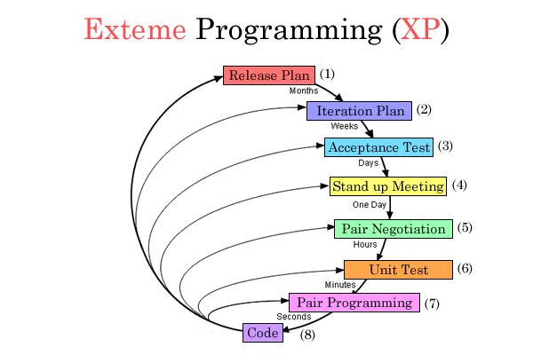

Figure 1 Alee62544.github.io. (2019). *Methodologies*. [online] Available at: https://alee62544.github.io/methodologies.html [Accessed 6 Dec. 2019].

Software development is a very dynamic process in which specifications cannot be completely anticipated from the start but will always shift as projects move forward. The Computerized Delivery Tracking System is a small project that has more requirements on coding which is the function needs. It will also require more on the efficiency of the developing process. Considering the characteristics of these projects is very consistent with the characteristics of Extreme Programming. I think Extreme Programming will be the best choice for developing this project.

The framework can be divided into these following steps:

1. **Release Plan**

In this phase, Sue and Tom (the company representatives of Waiters on Wheels) will be involved in the whole process to assist the development team. With the initial requirements from Sue and Tom, the team writes user stories to describe. After that, the teams will keep discussing with Sue and Tom whether the user Stories meet their expectations. At last, the team will prepare officially launch a small release detailing the overall project. Such as the duration and tasks for each stage. The user stories are as follow:

User stories:

* As a manager, I hope that I can query some customers' ordering records and credit records through this software.
* As a customer, I hope that I can query my food delivery information in real time through the software GPS positioning.
* As a customer, I want my personal information to be kept confidential.
* As a customer, I like to be able to order meals directly through the software, without calling
* As a merchant, I like that I can operate through software to notify customers when a customer order is placed and will arrive.

The team gets down to doing index card where user stories are written on with a name and a brief paragraph describing the story's intent and what the developer wants to do.

1. **Iteration Plan**

XP's plan to quickly put a simple system into development in the Iteration to Release Process and then release a new version in a short period of time. The group therefore decides to start multiple iterations and will take about 1~ 2 weeks for each iteration. This process requires the developer to review the current index cards and ensure that they know exactly what to do. Therefore, with the development of the study, it is important to model with a preliminary idea and begin the coding by implementing the pair programming technique in which the code is designed on the same computer by two programmers to reduce the risk of individual developers leaving.

The first iteration would make the project's main metaphor more clear. Sue and Tom, dig into the chosen story during the next iteration planning phase and want to add more information to the story based on the first iteration. Furthermore, these new user stories will not settle within this iteration to prevent the existing creation from disrupting. In the next version, it will patch. Repeated iterations are therefore required for the final specifications to be met. The group will then write test data and run practical evaluations, also known as acceptance tests.

1. **Acceptance Test**

The acceptance test is created based on the user stories that we selected in the iteration plan. The group must conduct practical checks like order system, driver execution, and restaurant monitoring until all task passes. Then, the team will try to find performance issues and performance tuning until the full functional iteration is done. To reach Sue and Tom's satisfaction, this experiment will be repeated several times. It is a black box system test so that user can lack in technology. If there is no issue for the testing result, then we will go to the next step, or we will go back to debug it. Nonetheless, even if there is no issue, this is not the final result.

1. **Stand up Meeting**

In this stage, all the developers and programmers in our team will meet together every day to communicate. The topic will about the problems our team faced and the solution of these problems. Such as, debug, trouble shooting, the interface designing etc. It’s a short meet, but everyone required to attend the meeting.

1. **Pair Negotiation**

Next, we are going to compare and combine our sets of design and implementation skills to produce the most suitable solution.

1. **Unit Test**

This stage we are going to test the all the classes in the system. Test if there are any bugs. Considering the resistance of the deadline and the costs, we are going to use automated test. We will ensure all the codes and functions can pass all the tests before the final release.

1. **Pair Programming**

In order to improve the accuracy, quality and efficiency of programming, we will adopt the pair programming mode for all programming processes. That is, two groups are used, and the same computer is used for programming. In this way, in the process of programming, the two programmers who cooperate can deliver high quality products as soon as possible.

1. **Code**

Finally, the code will combined with all the unit system that we have developed as the final product / software.

### Project Scheduling

Figure 2 Gantt Chart for Computerized Delivery Tracking System

## LEONG SOONG JUN TP050994

### Waterfall Methodology

Waterfall methodology is fundamental to the software development method. In addition, the waterfall model emphasized in every logical progression of steps is taken based on software development life cycle (SDLC). Hence, waterfall model is suitable for beginners since it can be used for various types of projects. Waterfall model is highly structured and rigid-sequential development process because, in order to proceed the next step, the previous steps must be well-coordinated or perfectly completed. Furthermore, waterfall model promotes quality control of process and product from its behaviours, especially focused on documentation.

Next, the stages of the waterfall model are explained, by applying in our software development process.

The first step of the waterfall model is requirement gathering. We received the complaints from the end-users of Whale of Wheels. For instances, the process of placing an order is time-consuming. The money flow which is calculated or checked manually lead to a very troublesome process. The workers of Whale of Wheels need to call the drivers directly through a phone call, this process may take some unnecessary time. We had concluded these problem statements, which turns into possible requirement of the system to be developed and documented into system requirement specification (SRS) document.

The second step of the waterfall model is system analysis. We studied the possible requirement from the system requirement specification (SRS) document and ready to prepare a new system to solve the issue that Whale of Wheels faced. We have referred the original system as a reference or a guideline which we coordinate with the previous business model since we wish to convenient the end-user with this system functions smoothly. Therefore, we have prepared these ideas, as an example, creates a system that can be used by different individual to perform different tasks simultaneously and respectively.

The third step of the waterfall model is system design. After we analyse the possible outcome, nevertheless, this stage is required to consider the types of programming languages, data layers, services etc. Various design specifications are created to fulfil the compatibility of the programming languages combine with other specific features. In this case, we decided to develop an object-oriented system that receives bills, orders etc which can easily used by others reached the features.

The fourth step of the waterfall model is implementation. With the inputs from system design, the system is developed into mini functional application, which meant to integrate into the next phase to form a complete system. In this step, unit testing is implemented in this section to test every developed unit’s functionality. For example, we try to introduce a cashless system to ease the end-user to save their valuable time. Apart from that, we also test on creating new account features in term of duplicate account. We also test on the double charge of QR code scanner or payWave.

The fifth step of the waterfall model is integration. Every mini functional application will be combined into a fully functional piece of system after the units are tested. During this stage, we performed a beta test to allow the end-user to experience our system, wish to discover and report some issues to do final correction. This beta test technically will help to reveal a visible or invisible bug that hides within the system, then, we will figure a new way to fix the failure function.

The sixth step of the waterfall model is deployment of system. After the functional and non-functional testing is done, the system is ready to deploy to the new environment eventually. A new system is built and presented based on the criteria of the end-users to a new platform. End-user will accept our end-product which is agreed to finish before the deadline and followed by the requirement of the end-users.

The seventh step of the waterfall model is maintenance. Although we have released the final version of the system there will occur some issues which will show up after end-user had used severe times. Hence, we as a software developer is responsible to release new patches to fix those issues. Moreover, we will update the feature of the functions to improve the overall performance of all time for every end-user.

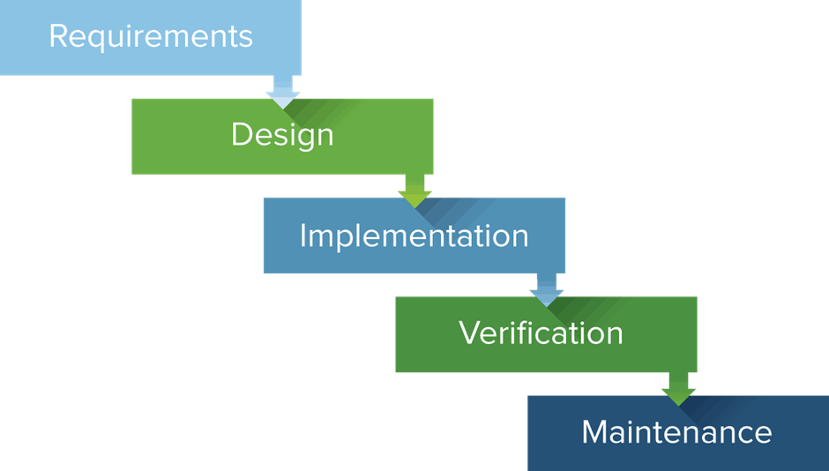

Figure 3: Waterfall Model

### Project Scheduling

Figure 3 is shown in a simple diagram of waterfall methodologies.

## LYU CHENYANG TP052020

### Scrum Methodology

Scrum was originally created to improve the efficiency of software development. This methodology is easily corrected for errors, which allows for faster coding and testing of fast-moving, cutting-edge development. Now, the impact of Scrum is not only in the field of software development but also in the commercial, military and educational fields. The reason I chose Agile Scrum is that companies can use it to help companies save time and money. And in several Agile Methodology, Scrum is very suitable for this short cycle project. It makes it easier to deliver quality products within a defined timeframe. The central idea of Scrum is to give control to the team that implements the work. It promotes efficient collaboration among team members, and every role and team in the operation of Scrum can be at the heart of the project. Create more value for the business.

The second reason is that it has a strictly controlled approach. This method is to meet frequently and update the progress of the work at the meeting. Each elite team or elite can share work progress with each other through daily meetings, which makes project development clearly visible. Improve work efficiency through the opinions of each team member. You can identify problems in advance through daily meetings and then focus on solving them. When the other party has a problem, everyone can help him together. So this can lead the entire team to complete the Sprint faster.

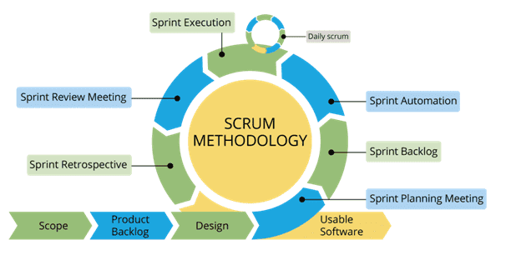

Figure Scrum Model <https://www.educba.com/what-is-scrum/>

The third reason is that it will iterate the end user's feedback as the core. Because Sprint's cycle is short and can receive constant feedback, it becomes easier to cope with product demands. The Product Owner meets the end-user or Product Owner by iteration, and the cost can be lower, so it is more in line with the development of this product.

**The Scrum Team**

Product Owner: He asks for the product's needs and is responsible for ensuring that the Backlog is up-to-date and responsible for the final effect of the product.

Scrum Master: Ensure that the team follows the agile Scrum correctly, hosts daily meetings, and manages the entire Scrum.

The Scrum Development Team: They are responsible for performing tasks and defining important levels of tasks. They have the responsibility for the research and development of the entire project.

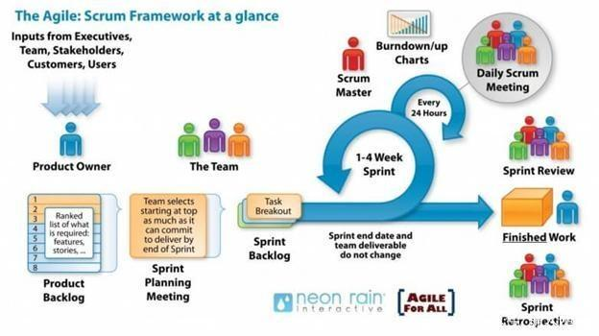

Figure <https://www.neonrain.com/agile-scrum-web-development/>

Whenever end-user request a new feature. The Scrum will begin to develop a project plan in one day. Upon completion, they distributed the backlog of the project to the Scrum team and found the requirements for Product Owner and End-user within the next day. Finally, the team will conduct The Sprint review, which is to let the Scrum team show the Product Owner the work done during the Sprint.

After the delivery of the Backlog, we will hold a meeting to assign tasks within one day. Our team will analyze the system requirements or the current troubles within 4 days. And design a GUI, Interface, chart and other systems. Then we will start building the product system with code in two days. In this process, the team will often test the system together. If you find a problem with the system, the team will work together and solve it. If the system does not find a problem, we will post it to the end-user experience. Then teach them how to use the product. The experience can be completed in one day.

### Project Scheduling

## TAN WEIXIAN TP048417

### WISDM Methodology

WISDM Methodology is an information system development methodology that are specialized at websites or web applications. The general framework of WISDM contains three elements: the change agents, the situation, and the ISD methods. WISDM focuses on the methods matrix (shown in the following figure below), which categorizes methods in two dimensions: socio (organizational and individual concern) and technological (the ' stuff ' concern), and analysis (' what ' is required) and development (' how ' it will be achieved). WISDM Methodology has a Multiview approaches and it contains five phases: Organizational Analysis, Information Analysis, Work Design, Technical Design, Human-Computer Interaction.

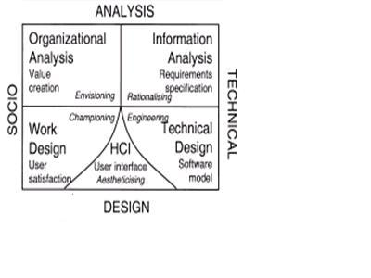

Figure 1

**Organizational Analysis**

Organizational Analysis is an analysis of benefit of this project to the company. The purpose of this is to make the company to be more competitive and create a strategy to beat out other competitors. As a recommendation, since this company is a food delivery company, the goal should be develop an phone application because it is more convenient to order by using phone, the services should be fast and good and the company should expand their company more by collaborating with other restaurants.

**Work Design**

Work Design is to focus the satisfaction of customer and employees in this e-commerce environment. Usability, information quality and accessibility are concerned by the customer and employee. Therefore, it is very important to establish relationship between customer and employee. My recommendation will be launching a survey at website that is created at Google Form to determine what customer do desire. After this, employee should analyse the result and choose the features.

**Information Analysis**

Web developer collects the user requirements from the organisation in this phase. The user requirement is a tool for web developer to construct UML model for this project and covers the specific needs of the users, system administration requirements, functional and non-functional requirements as well as the system’s requirements.

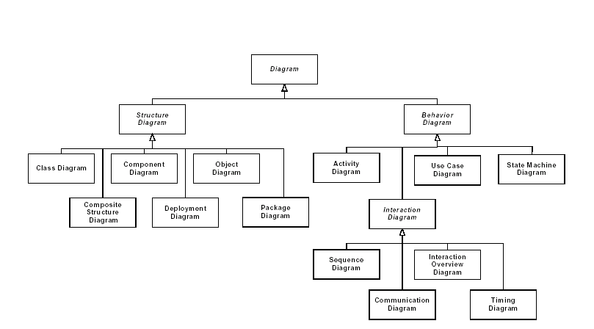

Figure 2

**Technical Design**

This stage started the Design Phase and involves designing the software system that has been proposed during Analysis Phase. Web designer will need to think what framework or software should be used in this project and also concerned about the data relationship in this application.

The web developer designs the website as to the look and feel for the customer. When the developer designs the website, they should focus on following points:

* Purpose of the website
* Subject of the website
* Target what the customer feels about the website (Graphical User Interface)

Web designer need to draw Entity Relationship Diagram to illustrate the data relationship. For this project, I would recommend JavaScript as our internet and implantation technologies because JavaScript is a powerful web coding language and its functionality is better than others.

**Human Computer Interaction**

During this phase, the web designer should concern about the interaction between user interface and customer (GUI). Web designer should design the website based on the customers’ requirement. For example, you can think like what is my customer, a novice or a expert user? Should I give this system more complex or simple? As my recommendation, our application should be simple since our target is ordinary user, not professional. The main page should have recommendation system to recommend some discounted foods at there.

### Project Scheduling

# Reference

groovyPost. (2019). *What is Microsoft Visio and What Does it Do? | groovyPost*. [online] Available at: https://www.groovypost.com/reviews/microsoft-visio-explained/ [Accessed 6 Dec. 2019].

Android Authority. (2019). *10 completely different IDEs and methods for making Android apps*. [online] Available at: https://www.androidauthority.com/10-completely-different-ides-and-methods-for-making-android-apps-701584/ [Accessed 6 Dec. 2019].

Slant, A., IDEA, I., Code, V., SDK, C., Creator, Q. and Rider, J. (2019). *Slant - Android Studio vs NetBeans IDE detailed comparison as of 2019*. [online] Slant. Available at: https://www.slant.co/versus/4368/10540/~android-studio_vs_netbeans-ide [Accessed 6 Dec. 2019].

StackShare. (2019). *Android Studio vs NetBeans IDE vs Visual Studio | What are the differences?* [online] Available at: https://stackshare.io/stackups/android-studio-vs-netbeans-vs-visual-studio [Accessed 6 Dec. 2019].

Developer.apple.com. (2019). *Swift - Apple Developer*. [online] Available at: https://developer.apple.com/swift/ [Accessed 6 Dec. 2019].

Careerfoundry.com. (2019). *A Step-By-Step Guide To The Programming Language Swift*. [online] Available at: https://careerfoundry.com/en/blog/ios-development/introduction-to-swift-for-non-programmers/ [Accessed 6 Dec. 2019].

Wells, D. (2019). *Release Planning*. [online] Extremeprogramming.org. Available at: http://www.extremeprogramming.org/rules/planninggame.html [Accessed 6 Dec. 2019].

Resources.collab.net. (2019). *What Is Scrum Methodology?*. [online] Available at: https://resources.collab.net/agile-101/what-is-scrum [Accessed 6 Dec. 2019].

Baijiahao.baidu.com. (2019). *Scrum/Agile*. [online] Available at: https://baijiahao.baidu.com/s?id=1622731643386356451&wfr=spider&for=pc [Accessed 6 Dec. 2019].

Business News Daily. (2019). *What Is Agile Scrum Methodology?* [online] Available at: https://www.businessnewsdaily.com/4987-what-is-agile-scrum-methodology.html [Accessed 6 Dec. 2019].

Cnblogs.com. (2019). *Are you really know Scrum?* [online] Available at: https://www.cnblogs.com/bootsagile/p/9567114.html [Accessed 6 Dec. 2019].

Ictsmart.tripod.com. (2004). *Implementation: Changeover Methods*. [online] Available at: http://ictsmart.tripod.com/ict4/print/partimcm.htm [Accessed 17 Nov. 2019].

Jackson, O., 2014. System Implementation. [Online] Available at: https://www.slideshare.net/omwoma/l10-system-implementation [Accessed 23 Nov 2019].

Smartsheet. (2019). Waterfall. [online] Available at: https://www.smartsheet.com/content-center/best-practices/project-management/project-management-guide/waterfall-methodology.

Smartsheet.com. (2019). [online] Available at: https://www.smartsheet.com/sites/default/files/waterfall%402x.png [Accessed 4 Dec. 2019].